Joshua Paul Barnard’s Final Project Proposal

CS 17.11 – Java Programming

Spring 2018, SRJC

I want to make a story-driven game based on two of the most unpopular game styles: text-based and idling… The users primary interface with the game will be reading/typing in the primary console, in the middle of the window. There will be mouse interactivity with the menu/status bar ontop, and the 2 window panes on the right, and two on the left. The game progresses by the player leaving the game running on their computer. Over time random events will occur which will be affected by the players choices.

The story will be my own, with essences of Dune and The Matrix. The user will start by choosing a name and base class (potentially: initiate, military operative, vagabond). The user will start by reading the story of their class, then the “beginning” of the game will start. (The game will begin with the user floating in space finding their new selves. For the initiate class this will be very quick (less than 30minutes), vagabond will take a very long time (1day+). )

Once the user is “found”, the real game will begin. While in a users “station” they will be free from negative random events, but the random events will be seldom and lame. The player will start learning a space travel skill, and once high enough they will be able to start traveling to other planets. It is on these other planets that the player will encounter different types of random events which will involve the players stats and skills to determine success or failures. If the users HP/CP drop to 0 they will return to their “station” and must wait some time to recover.

The game is open ended, with the user spending their time exploring planets, collecting/crafting items, and defeating strong opposites (which will only occur in random events in certain area’s). Planets (and “stations”) will have small maps, the player will have the choice to turn on/off autowandering (ie, the player will move around the map automatically, or not). Some area’s may have people to talk to, though no interactivity is planned.

**User Interface:**

* The users primary interface with the game will be reading and typing text into the main console.
* A secondary console will above the primary console to log and display major events.
* The menu bar, inventories window pane, equipped items/crafting recipes, map, and travel options window panes will all allow for interactivity with the mouse, though text commands will also exist.

**Items:**

* There will be ingame items which will be acquired by random event, defeating enemies, and crafting.
* There will be a crafting option, which will consist of creating in game items using recipes and crafting resources. There will be three crafting resources, currently planned to named: electrons, protons, neutrons.
* Items will be displayed in the users Inventory window pane.
* Equipped Items and Crafting Recipes will be displayed in the users Equipped Items window pane, and the user can switch them using the menu bar or typing a command.
* Items can be deleted by removing them from the players inventory.

**The menu and status bar; will consist of two distinct sections spanning the entire top of the screen.**

* The menu bar will be in the very top left corner of the screen, and is planned to contain two menu’s.
* The first menu will contain the save and load options, along with an exit option.
* The second menu will allow the user to easily switch the equipped items window, between equipped items and crafting recipes.
* The second menu will also allow the user to easily switch between galactic map, and local map.
* Any additional UI changes will be in the second menu.
* The status bar will be to the very top right of the screen.
* The status bar will display the players health, constitution, experience points, crafting resources, and money in text.

**Users Player:**

* The users player will consist of a base class, which affects the players starting situation, starting stats, and affects ongoing random events.
* The player will have statistics which will include (but not limited to): Will power, constitution, dexterity, intelligence.
* Status will consist of health points and constitution points. Health points will be based on will power and constitution. Constitution points will be based on constitution.
* Players stats will affect random game events.
* There will be skills to affect ingame processes, such as martial arts training to increase hand-to-hand fighting skills, cybersecurity for breaking into systems, etc.
* Stats will help or harm different skills.
* Skills will affect random in game events.

Here is a mockup I made for the general user interface.

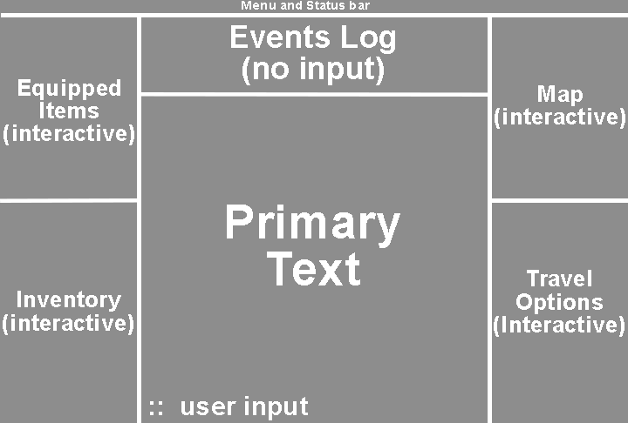

Here is a screenshot of another text-based game.

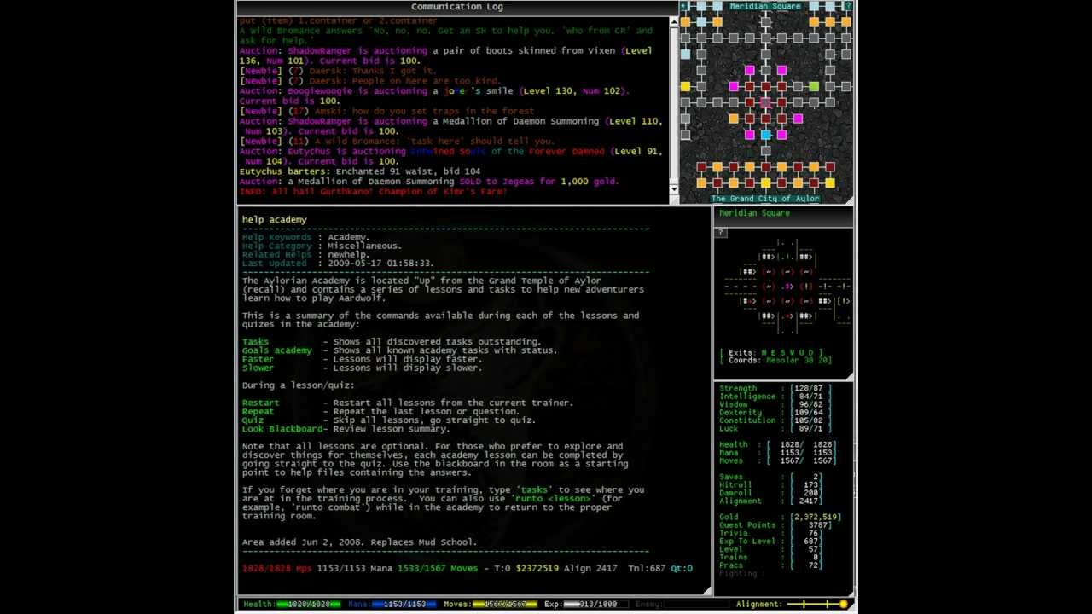

Here are some examples:

Skid Inc – Hacker-themed text-based incremental game: https://skid-inc.totominc.io/

DiscWorld MUD – multiplayer, text-based online game: http://discworld.starturtle.net/lpc/